|  |
| --- |
|  |
| Christmas Newsletter |
|  |

**School Website**: [www.crosserloughns.com](http://www.crosserloughns.com)

# Upcoming Events

## *December 18*

*Christmas Song and dance with Mary Farrelly*

## *December 21*

*Christmas Dash in aid of SVP*

*Wear Xmas jumper*

***December 21***

*Virtual Christmas Pantomine for all classes (to be confirmed)*

***December 22***

*Christmas Holidays- school closing at 12 p.m.*

***January 6***

*Return to school after Christmas Holidays*

|  |
| --- |
|  |
| School Enrolment 2021 Application for school enrolment in Crosserlough NS will occur in February. It will be advertised in the church newsletter, the school website and the Anglo Celt.  School enrolment packs can be collected from the office in February. |

**email:** [crosserloughns1@eircom.net](mailto:crosserloughns1@eircom.net) **Phone**: *049-4336128*

|  |
| --- |
|  |
| *Dear Parents/Guardians*  *As we approach the Christmas holidays, I wish to update you on school activity. 2020 is certainly a year we are all looking forward to putting behind us. It has been difficult for everyone but especially for families who have lost loved ones this year. May they Rest in Peace.* |
|  |

***First Confessions and First Holy Communion***

*After 4 months of home-schooling we were all delighted to return to school in September. Since then, pupils in 3rd class celebrated their First Confessions and First Holy Communion. It was a lovely family occasion and the children enjoyed the party that followed the next day in school. I would like to thank the Parents Association for the lovely gift bags they prepared for every pupil.*

***Photographs***

*Memory Lane Photographer took lovely photos and families who purchased photographs will have received them.*

***Coding***

*During the month of October, pupils had the opportunity to engage in Coding. 1st & 2nd class played and coded Beebots. 3rd to 6th class enjoyed building and coding lego using legowedo and they also had fun coding spheros- a sphere robot controlled by a tablet.*

|  |
| --- |
|  |
|  |

***Master McDermott’s Retirement***

*As we approached the Halloween break, Covid19 spread quickly throughout the parish and this affected school attendance. Sadly, we were unable to have a proper farewell for Master McDermott but he was overwhelmed and totally taken aback by the “drive-by” farewell which was kindly organised by the parents.*

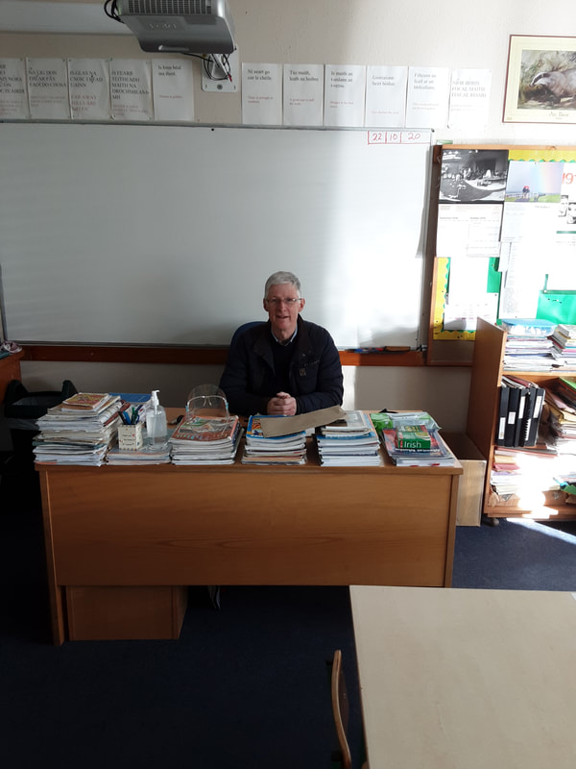

# 

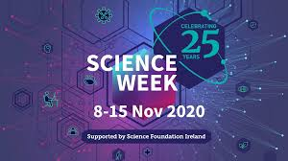

|  |
| --- |
|  |
|  |

***Photography and Animation Workshops***

*Since returning after Halloween, 5th & 6th class engaged in Zoom workshops in Photography and Animation. Each week they are learning new skills in photography which will help them to produce a short animation movie using an app “Stopmotion”. The workshops are funded by the Creative Ireland €2000 grant we received after a successful application.*

***Science Week*** *As part of Science week 5th & 6th class engaged in a Zoom workshop on building Geodesic domes using straws and copper fasteners. They were delighted with their finished structure which they brought home. This event was organised by Cavan Library services. We would like to thank Carmel Cusack Smith for notifying the school about the event.*

***Percussion Workshop***

*On Wednesday, December 9th, the pupils enjoyed participating in a percussion workshop with Peter Crann.*

***Parent’s Association Raffle***

*The Parent’s Association is planning a raffle which will hopefully take place after Christmas. Tickets will be distributed before Christmas. I would like to thank the Parents for their continued support agus Le Cúnamh Dé we will be able to return to some normality in 2021.*

***Extra Curricular Activity***

*As regards sporting events, Cumann na mBunscol and cross-country were cancelled. Swimming lessons were also cancelled. The GAA coach, Keith Greene, has coached the pupils once a fortnight since September. Dance lessons will begin after Christmas with Mary Farrelly.*

***Parent/teacher Meetings***

*Parent/teacher meetings cannot take place face to face this term. Instead, the teachers will send a written report to parents in Jan/Feb and parents who have any concerns may ring Bríd to arrange a meeting over the phone with the teachers. Special Ed. Teachers have been in contact with parents of children who are in receipt of support.*

***ICT***- *Every pupil has been assigned a tablet for use in the class. Senior classes have an office 365 account to present project work or presentations using MS Powerpoint. Every pupil has a classdojo account where they can upload work completed for parents and teacher to view and comment on.*

***Staffing***

*I wish to congratulate Mrs Siobhán Clarke on her recent appointment as Deputy Principal. Miss Colette Donohoe joined us after Halloween and is teaching infants. She will be with us until June 2021. Miss Moyra McGoohan is teaching pupils with special needs along with Mrs Noreen Doherty and Mrs Debbie Coleman who are job-sharing. Mrs Fiona O Reilly is teaching 1st & 2nd class. Mrs Siobhan Clarke is teaching 5th & 6th class. I’m currently teaching 3rd & 4th class. Miss Edel Mc Dermott comes every Friday to teach my class while I attend to administrative duties. Mrs Geraldine Farmer is our Special needs Assistant. Bríd McEvoy is the school secretary.*

***Child Protection***

*Each year a review of Child Protection must be completed by the BOM. A recent review of Child Protection was completed by the BOM on December 3rd. The BOM adapted and ratified the appointment of Mrs Teresa Galligan as DLP and Mrs Siobhan Clarke as DDLP. The Child Safe Guarding Statement and Child Protection Policy have been amended, updated and will be published on the school website-* [*www.crosserloughns.com*](http://www.crosserloughns.com)*. If any parent wishes to receive a hard copy of the policy you may contact Bríd and she will email a copy*.

**School Closure**

*We will be closing on December 22nd at 12p.m. We return to school after Christmas on January 6th. Please find attached the school Calendar which is also published on the school website.*

*Finally, on behalf of the staff I want to wish every family a Merry Christmas, Good Health and Happiness for 2021. I urge everyone to adhere to the government guidelines so that we can return to school in January. Once again, thank you all so much for your continued support.*

*Nollaig Shona Dhaoibh go léir.*

Mise le Meas,

Teresa Galligan