Volcanoes
The rock at the very bottom of the earth is melting rock called magma.
The hot liquid (lava) erupts and comes out of a vent called a crater.
When the Lava cools it hardens into rock.
Every time a volcano erupts a new layer of rock is formed when it cools down. The volcano grows in size.
Some volcanoes spurt out Lava while in other volcanoes the lava just flows down the sides.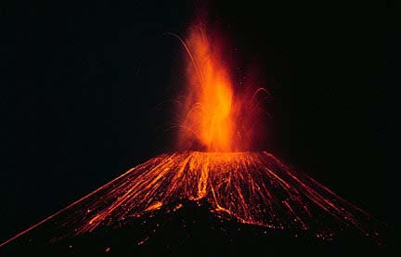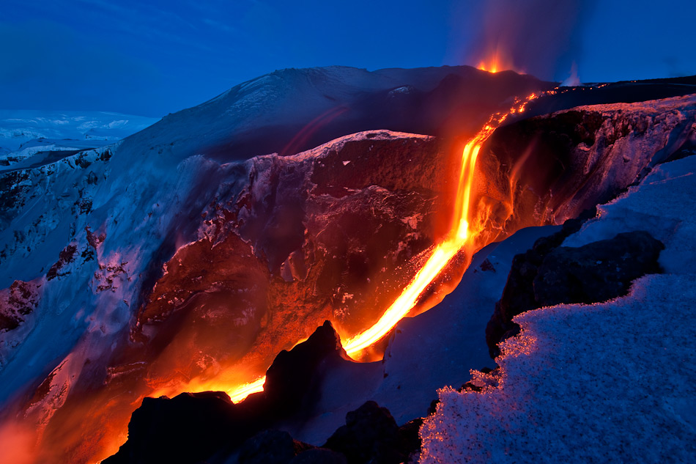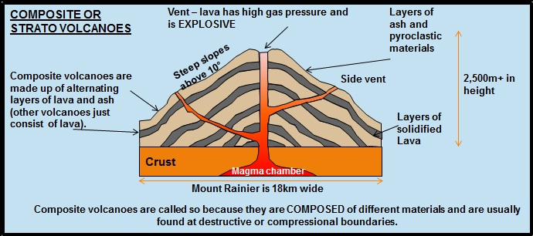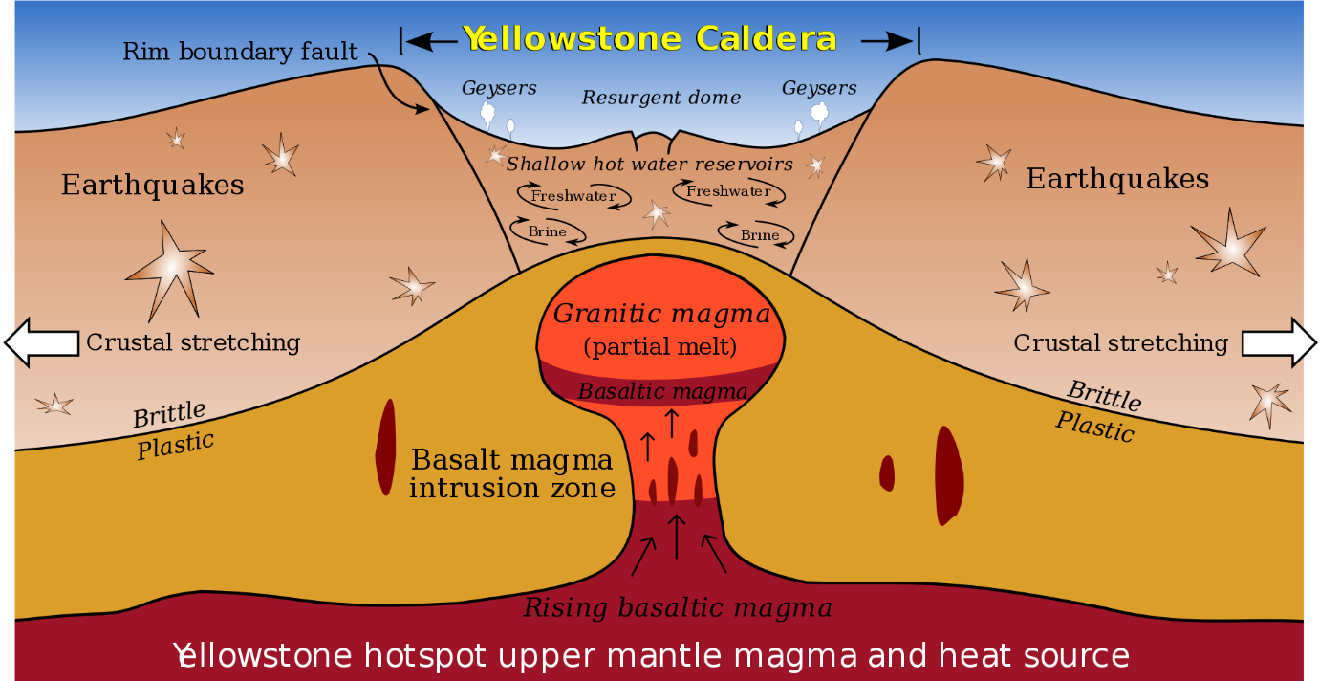
This Photo by Unknown Author is licensed under CC BY-SA
This Photo by Unknown Author is licensed under CC BY-NC-ND
This Photo by Unknown Author is licensed under CC BY-NC
This Photo by Unknown Author is licensed under CC BY-SA

